Chapter 3
DISCUSSION OF FINDINGS
This chapter presents and discusses the findings to the statement of the problem such as information requirements needed in the system, features of the proposed system, architectural design, physical design, information extraction model utilized in the system, and the level of the usability of the system as perceived by stakeholders of the proposed system.
Information Requirements Needed in the Proposed System
Information is most important part in every decision that is make. These information requirements serve as the basis for what information to extract and used in the proposed system.
SPDRRMO Information Requirements. The SPDRRMO information requirements are information obtained by the office and from other offices concern. The information covers the casualties, Damages, lifelines, and the local actions of the office in response to the disaster shown in Figure 2.

Figure 2
Information Requirement of Damage Assessment report
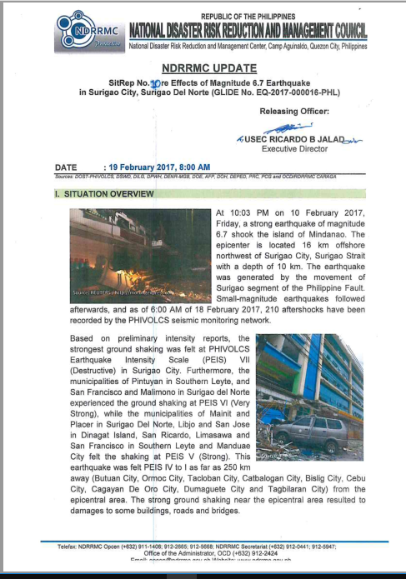
The Damage assessment report is divided into three categories this is situation overview, it contains information about the current situation of a disasters, effects which includes the affected population, casualties, damages, and status of lifelines, and disaster response, figure 3 show information requirement on effects
Figure 3
Information Requirement on effects
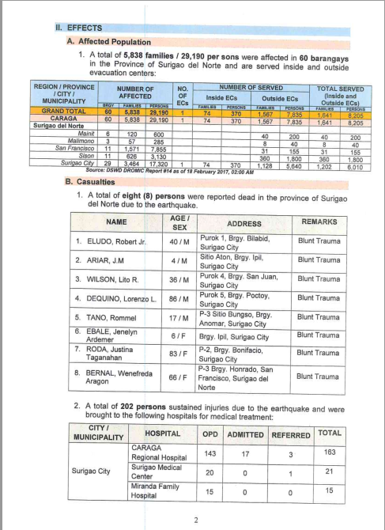
The effects information requirement shows the damages of houses, damaged facilities and Infrastructure, these include schools, health center and other facilities that was damage in a disaster, and the cost of damages, status of lifelines these includes the roads & bridge, power and water supply.
The actions and response of the SPDRRMC are also included in order to identify and assess the activities extended and for the LGU’s, NGO, and volunteers to adjust and plan out what possible actions that are necessary over the said disaster. Figure 4 show the information requirements for Disaster response
The information requirements for disaster response show the action taken by the SPDRRMC in response to a disaster these includes immediately dissemination of information to local governments and concerned stakeholders, and advised them to undertake initiative/response actions and to continuously monitor the situation.

Figure 4
Information Requirements on Disaster Response
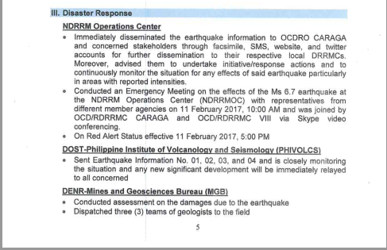
Social Media Disaster Related post. The information requirement social media disaster related posts are text extracted from social media platform which includes text that is related to disaster. Because the text are unorganized and contains some special characters the text is need to be cleaned and remove special characters. Figure 5 shows text with special characters and text after cleaning and removing those special characters.

Figure 5.1
Texts with special characters
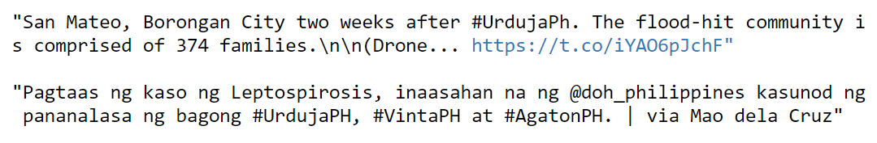

Figure 5.2
Text with removed special characters
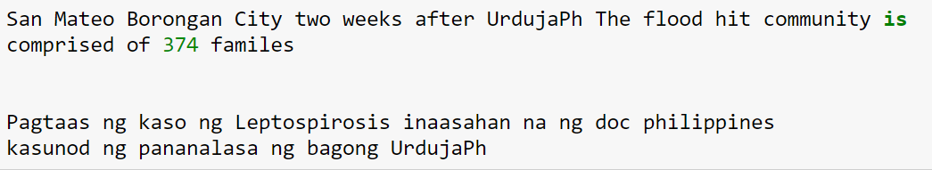

Information Extraction Model Utilized in the Proposed System
Information from social media have helped individuals, institutions and organizations (government, public, and private) during emergency response, in making decisions, and conducting relief efforts. The proposed system do this by extracting disaster related information from social media and present them in an ontology that can be used for disaster response and decisions making. Figure 6 shows how the proposed system Extract disaster related post from social media.
Figure 6
Extraction of disaster related post
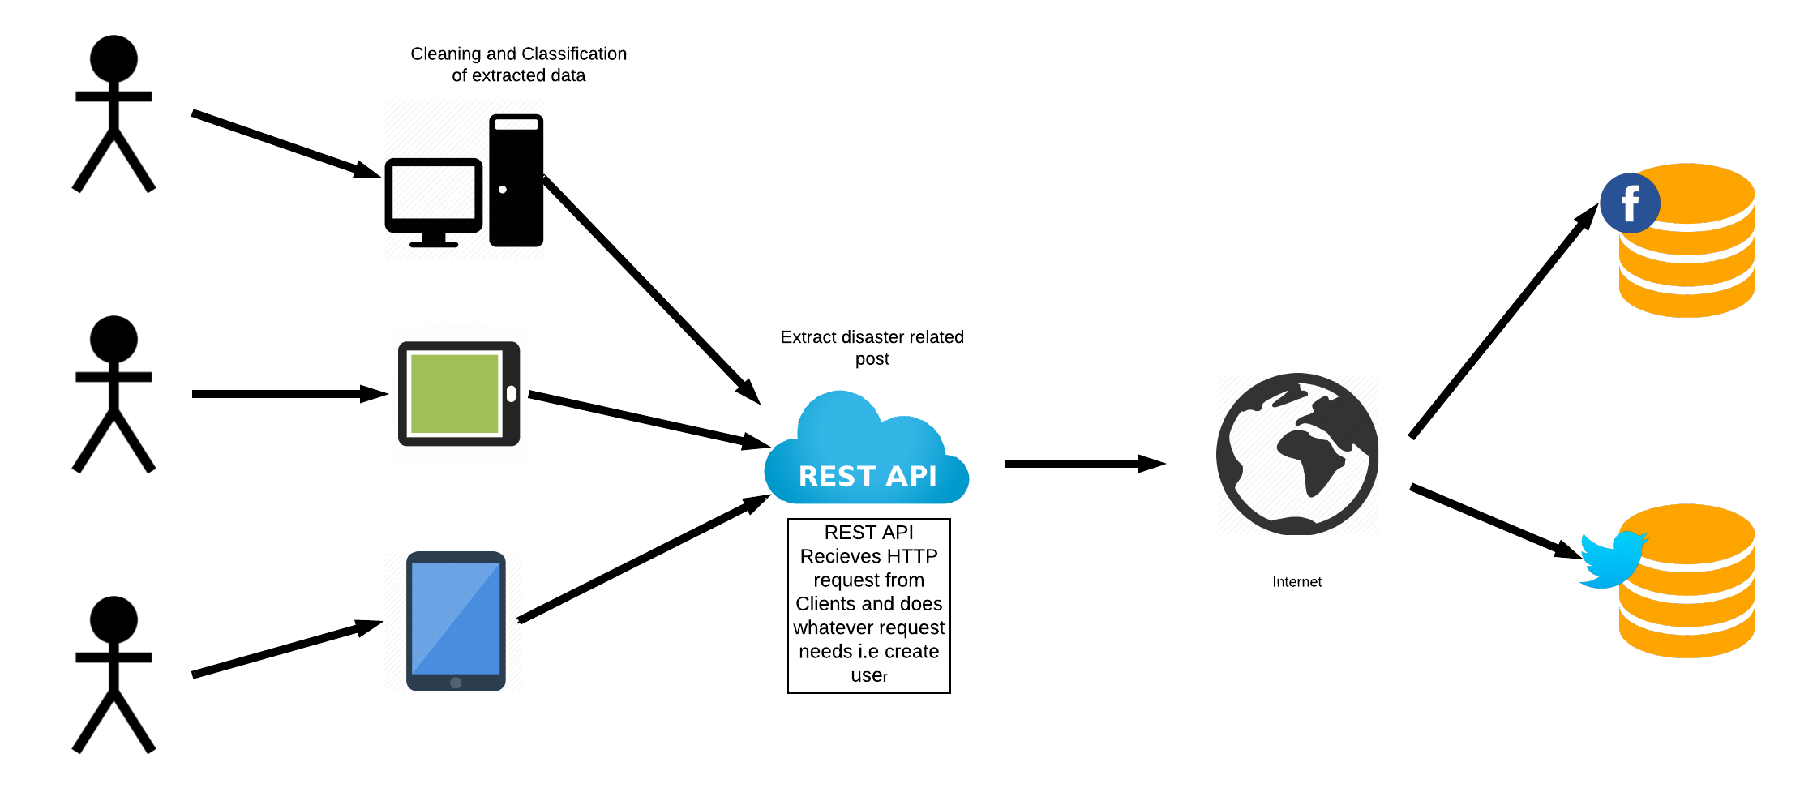
The figure above shows how the proposed system extract disaster related posts from social media. The system used REST API to query a search (i.e. keyword or Hashtag) from social media, this will get all the post that contains the keywords provided by the system user. The REST API then return a JSON formatted file this contains the data or the posts extracted from social media based on the keyword provided. The proposed system then clean the data, this is removing any special character in the extracted post, then the classification module will do its classification to classify the text into a categories. Figure 6 shows a detail example of the REST API request and response process.
RESTful API. The proposed system retrieve social media post by using REST API it uses HTTP requests to GET, PUT, POST and DELETE data. The proposed system uses this API to communicate and retrieve the posts information. Because of this API the system has no problem with authentication that is required by most social media to communicate with external system that may request the services of their platform. Figure 6 shows the REST API request and response process.
Figure 6
RESTful API
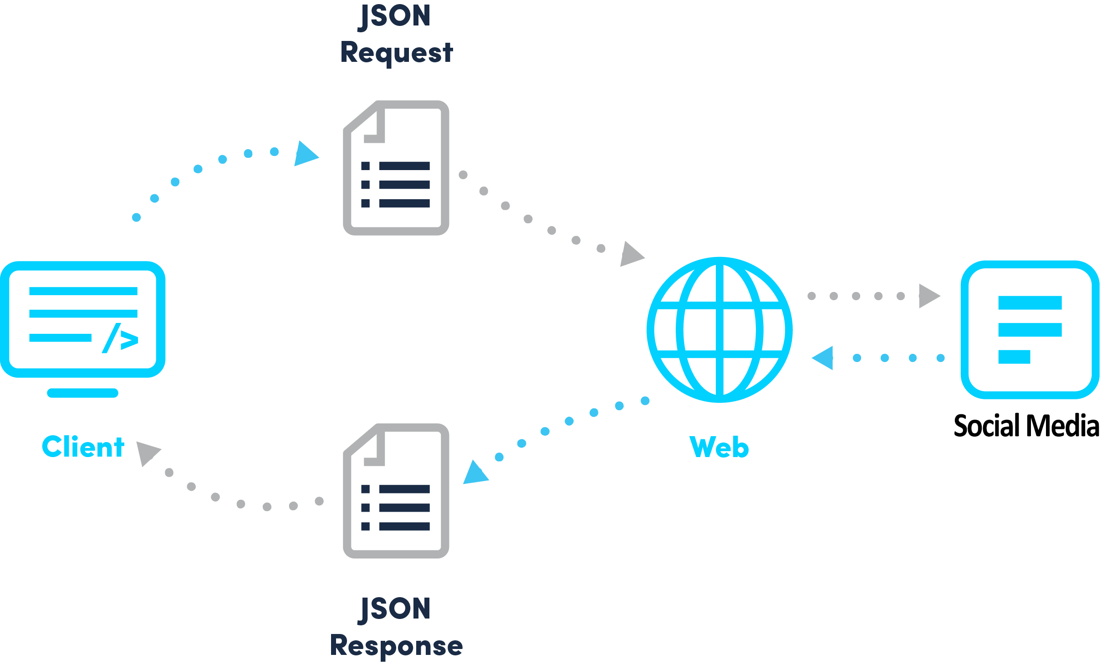
Open Authorization (OAuth)
Before the proposed system can do the searching of keywords/hashtag and extraction of information from social media posts, the proposed system needs to authenticate itself from the services that it request to use. OAuth allows secure authorization protocol that deals with this process Figure 7.1 shows the access keys used by OAuth to authenticate the proposed system. The system uses OAuth for secure connection and accessing the user public data from social media. Figure 7.2 show how the system utilize this to extract disaster related information from social media.
Figure 7.1
Proposed system OAuth access keys
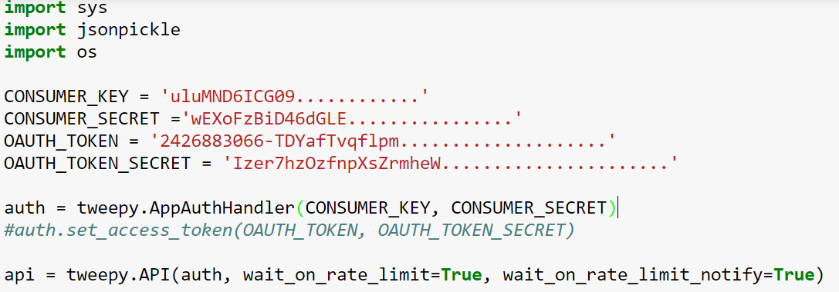
Figure 7.2
Proposed system Open Authentication
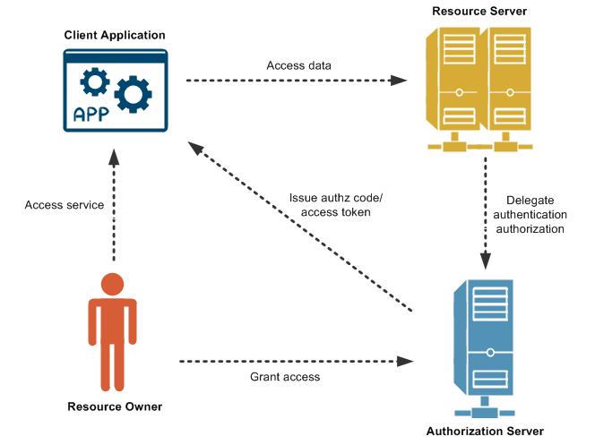
This returns JavaScript Object Notation (JSON format) with unstructured text and other information about the extracted posts that the proposed system needs to clean and format for category classification. The system will forward this unstructured text to the category classification module which clean and remove special characters. After this, the system now will do its classification using multinomial naïve Bayes then update its category count to update data presentation in the front end of the proposed system.
Multinomial Naïve Bayes for the Proposed study
To classify the cleaned extracted social media posts the researcher’s used the Multinomial Naïve Bayes. Naïve Bayes is a family of probabilistic algorithms that take advantage of probability theory and Bayes Theorem to predict the category of sample. Table 1 shows sample trained data in the proposed system.
Table 1
Trained data example
TEXT | CATEGORY
“Kailangan ng Donation sa Marawi” | Donation
“Marami ang Namatay sa baha” | Casualty & Damage
“Marami ang nag Donate” | Donation
“Salamat sa mga nag Donate” | Donation
“Ang laki ng itinaas ng baha marami na ang nasisira” | Casualty & Damage

The above table shows the sample trained data in the proposed system. To demonstrate on how to classify the text “May mga taga ibang bansa na nag Donate” is Donation. The system needs to calculate its probability that the text is Donate, and the probability of the text is Casualty & Damage. For the system the probability, the system transform this into something that can be calculated using word frequencies. Since the system using the Bayes’ Theorem
For example: 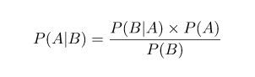
Using this theorem the system can reverse the conditional probability:
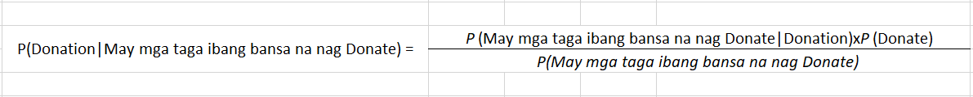
Since the system is just trying out how to find which category has a bigger probability, the system algorithm can now discard the divisor which is the same for both categories and just compare:
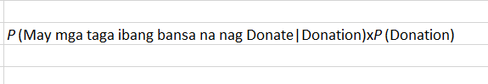
With
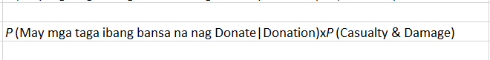
This is better, since the system algorithm could actually calculate these probabilities. The proposed system calculation for this is by just counting how many times the sentence “May mga taga ibang bansa na nag Donate” appears in the Donate category, divide it by the total, and obtain P(May mga taga ibang bansa na nag Donate|Donate). There’s a problem though: “May mga taga ibang bansa na nag Donate” doesn’t appear in the training set, so this probability is zero. Unless every sentence that the system classify appears in the training set.
The since the system uses Naïve Bayes Algorithm, the system just assume that every word in a sentence is independent of the other ones. This means that the system no longer looking at entire sentences, but rather at individual words for example:
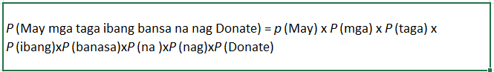
This assumption is very strong but super useful. Its what makes this model work well with little data or data that may be mislabeled. So the system will add this to the previous conditional probability:
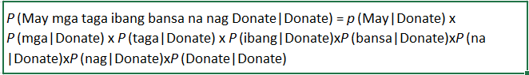
So now this individual words might appear in the training set, so the systems algorithm now can calculate them.
Calculation probabilities. The final step the system do is to just calculate every probability and see which one turns out to be larger. Calculating the probability is just counting to the training set. For example, calculating P(Donation|Donation) means counting how many times the word “Donation” appears in Donation samples(3) divided by the total number of words in Donation(14). Therefore, P(Donation|Donation) = 3/14. However, the system will run into a problem because “May”, “mga”, “taga”, “ibang”, “bansa” “na” doesn’t appear in any Donation sample. That means that P(May|Donation), P(mga|Donation), P(taga|Donation), P(bansa|Donation), P(na|Donation) = 0. This is rather inconvenient since the system is going to be multiplying it with the other probabilities:
P(May|Donate) x P(mga|Donate) x P(taga|Donate) x P(ibang|Donate) x P(bansa|Donate) x P(na|Donate) x p(nag|Donate) x p(Donate|Donate).
This equals 0 since in a multiplication, if one of the terms is zero, the whole calculation is nullified. Doing things this way the system will not return any information at all. The solution to this is the system algorithm Multinomial Naïve Bayes by using something called Laplace smoothing, this add 1 to every count so it’s never zero. To balance this, the system add the number of possible words to the divisor, so the division will never be greater than 1.
Features of the proposed system
This section presents the features of the proposed system based on the information requirements gathered and extraction model identified by the researchers.
Social media posts text extractor settings. The posts text extractor settings includes the keyword to search or hashtag for twitter and the number of text to be extracted, the default is, it will extract all the post that contain the keyword or hashtag in a post. Figure 8 show the text extractor settings. The required information for the text extractor settings is the keyword or hashtag, this will be the basis of the return or response of the API, this is the post that includes that keyword.
Figure 8
Social media posts text extractor settings
##############Figure 8 here##############################
After setting this text extractor settings the system will start searching of the keyword/hashtag from social media and returns a text which is a posts that contains the keyword/hashtag set from the settings, because of how Filipino write their post on social media and the used of special characters, the text is not easily be classified, because of this the system needs to clean the returned text by formatting and removing special characters.
After cleaning the data (removing special characters) the system can now classify the extracted text using the category classifier module Figure 9 show the categories presented in the proposed system.
Figure 9
Proposed system category module
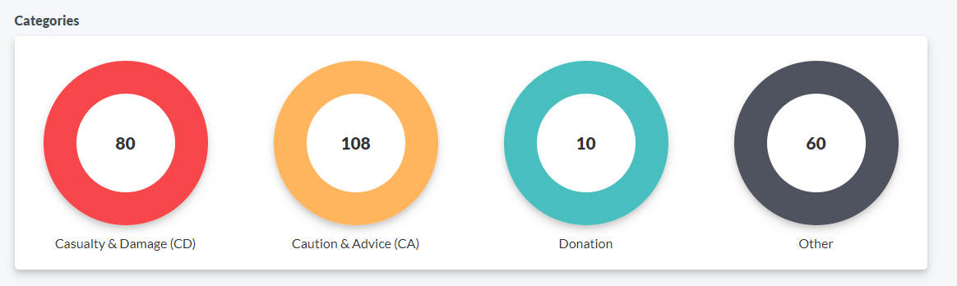
The category classifier module make used of the REST API to extract data, Figure 6 show the REST API diagram. The extracted text can be classify into four categories which is Casualty & Damage (CD), Caution & advice (CA), Donation and Other, other means, the text cannot be classify from the three categories and talks about other topic which is not related in the categories of the system. The number inside the categories indicate the number of text extracted that is classified in that category.
Social media posts training data setting
For a text to be classify into a categories, the system needs a trained data to use as reference for classification, each categories has its own trained data, Figure 11 shows the training data settings.

Figure 11
Training data setting
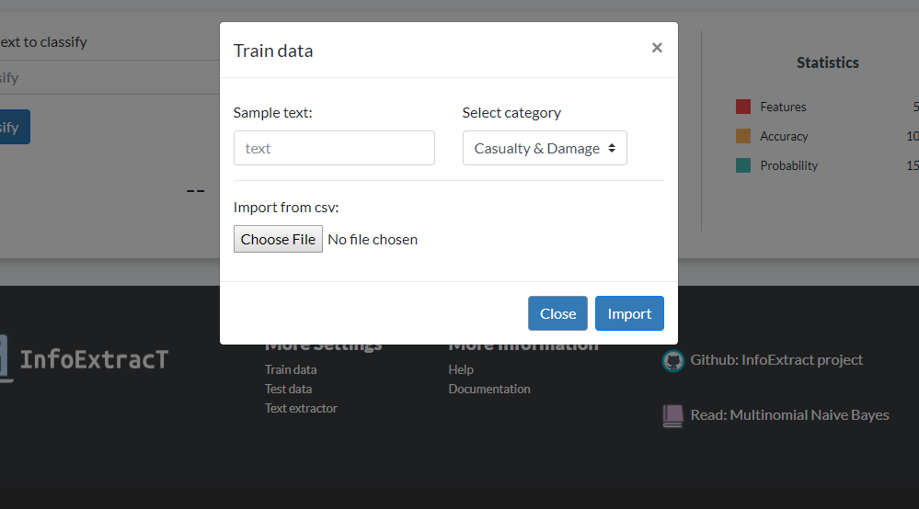
The required information for training data are the text and classification of that text. The system can also accept CSV format for easy and robust category text training. The text format for csv should be text fallowed by its category separated by a comma for example “Kailangan talaga ng maraming donation para sa Marawi.”,”Donation”.
Data presentation of extracted disaster related post. The data can be presented in three different ways in the system, this is bar graph, line graph and radar graph. The data presentation produced by the system can be a help for creating and prioritizing the activities needed to be done in times of a disaster Figure 12.1 shows the data presentation produced by the system.
Figure 12.1
Proposed system data presentation bar graph
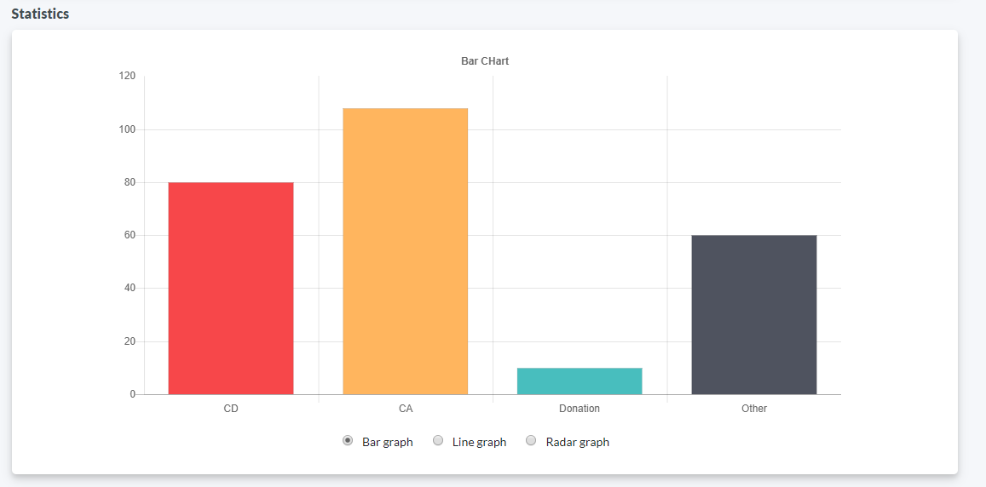
Figure 12.2
Proposed system data presentation line graph
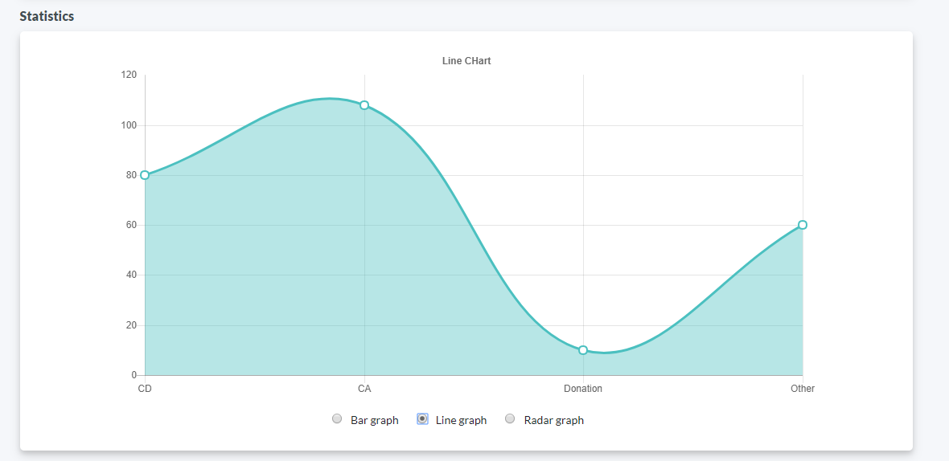
Figure 12.3
Proposed system data presentation radar graph
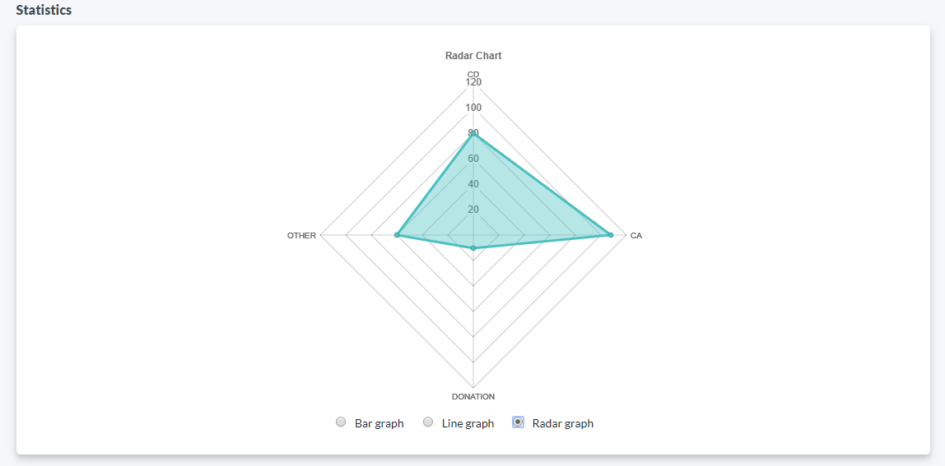
Level of Usability perceived by the stakeholder
This presents the level of usability as perceived by the stakeholder in the implementation of the proposed system. The level of acceptance was presented into assessment and operation. Aside from the perceived benefits, considerations in the proposed system are herewith presented.
System Usability Scale. System Usability Scale (SUS) is a reliable tool for measuring the usability. The researchers used this tool to test the usability of the proposed system using 11 item questionnaire with five response options for the respondents; from Strongly agree to Strongly disagree, Table 1 show System Usability Scale for the proposed system.
Table 1
System Usability Scale
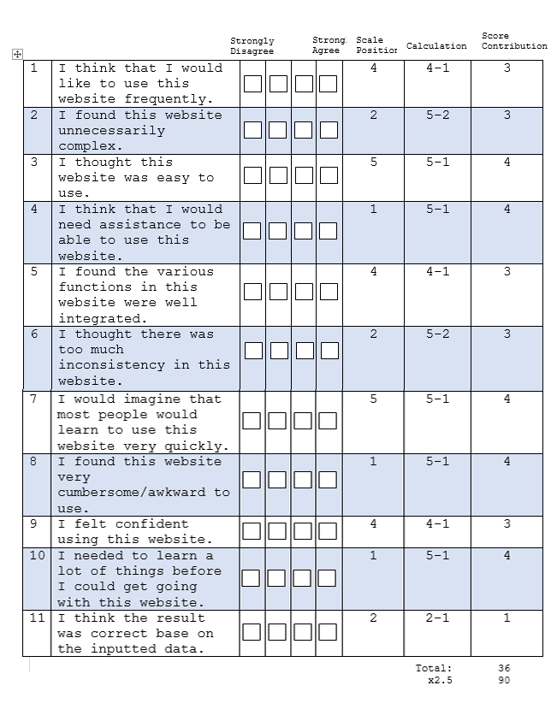
The table shows 11 questions and five response options for the proposed system to test its usability. The researchers then calculate the score of contribution for each statement. The calculation for System Usability Scale is, for odd numbered statements (1, 3, 5, 7, 9, and 11), the score contribution is equal to the scale position minus 1 and for even numbered statements (2, 4, 6, 8, and 10), the score contribution is equal to 5 minus the scale position. Each score contribution will fall within the range of 0 to 4. Once calculated all 11 scores, the researchers then multiply the sum of the scores by 2.5 which will produce the overall system usability value. These values will range from 0 to 100, Table 2 shows the proposed system overall usability value. The gathered data will then be compare to System Usability Scale Interpretation to get the result of the gathered usability data. Table 3 shows the System Usability Scale Interpretation, this is used by the researcher to know if the system was usable base on the gathered usability data.
Table 2
Proposed system overall usability value
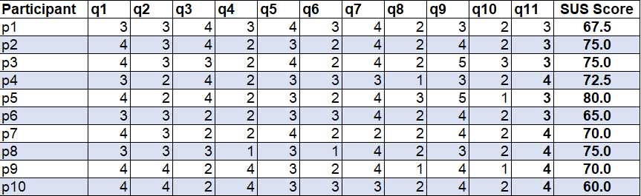
Table 3
System Usability Scale Interpretation
WORST IMAGINABLE | 0 | NOT ACCEPTABLE | F
WORST IMAGINABLE | 10 | NOT ACCEPTABLE | F
WORST IMAGINABLE | 15 | NOT ACCEPTABLE | F
WORST IMAGINABLE | 20 | NOT ACCEPTABLE | F
WORST IMAGINABLE | 25 | NOT ACCEPTABLE | F
POOR | 30 | NOT ACCEPTABLE | F
POOR | 35 | NOT ACCEPTABLE | F
POOR | 40 | NOT ACCEPTABLE | F
POOR | 45 | NOT ACCEPTABLE | F
OK | 50 | NOT ACCEPTABLE | F
OK | 55 | NOT ACCEPTABLE | F
OK | 60 | NOT ACCEPTABLE | D
OK | 65 | ACCEPTABLE | D
OK | 70 | ACCEPTABLE | C
GOOD | 75 | ACCEPTABLE | C
GOOD | 80 | ACCEPTABLE | B
GOOD | 85 | ACCEPTABLE | B
EXCELLENT | 90 | ACCEPTABLE | A
BEST IMAGINABLE | 100 | ACCEPTABLE | A

With the used of System Usability Scale Interpretation the researchers then get the proposed system usability. The scale of from 0 to 20 means that the system was Worst Imaginable and not acceptable, from 30 to 40 this means that the system usability is Poor and still not acceptable, from 50 to 70 means that the system is Good but it is still not acceptable, from 80 to 90 the system rating is Excellent this means that the system is acceptable base on the SUS questions provided by the researchers, and 100 means Best Imaginable this is the highest rating for the System Usability Scale Interpretation. The researchers used this as a basis for the usability of the proposed system.
Table 4 shows the System Usability Scale Interpretation of the proposed system. This means that the system get a number of 3 OK and 7 good Interpretation. The participant believed that the system can be more improved to increase it rate of usability. Based on the System Usability Scale participants conclude that various functions of the system were well integrated and it is beneficial to be used by the SPDRRMC for their basis of disaster planning and activities due to the increase of population that used social media to post information about their situation in times of a disaster.
Table 4
System Usability Scale Interpretation
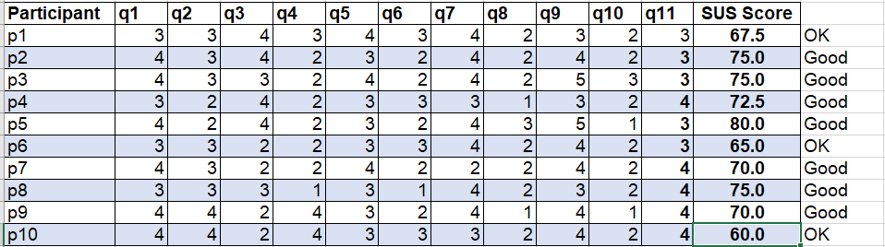
The participants also noticed that the result of the data that their inputted in the system, this is the search query for keywords/hashtag was not returning 100% correct, this means that the system categorization module should be improved and to increase the level of its ussability. Based from the results, the researcher therefore concluded that the stakeholder and the level of ussability was sufficient enough to implement the proposed system and improved its categorization module. And, that this shall benefit the SPDRRMC including those external users who are part of the provincial disaster operations and Non government Organization.
System Design
To provide a clearer interpretation of the proposed study, this sections presents the logical and physical design of the proposed system.
The study adapted the input, output concept for it covers the scope where several factors are considered such as communication, processes, policies, human resource among others as shown in Figure 11. The input consists of the information requirements needed, damage assestment reports, and the used of social media for information extraction of disaster related post.
The researcher’s interviewed the Provincial Disaster Risk Reduction Management Council (SPDRRMC) this cover the information requirements under study specifically along the activities done in response to a disasters. These information requirements served as information requirement of the SPDRRMC in creating plans, activies in times of disaster. And also, the awareness of the community/volunteer on technology such social media, on information extraction of disaster related post. This refers to the input activities of the study.
Figure 13
Conceptual Design
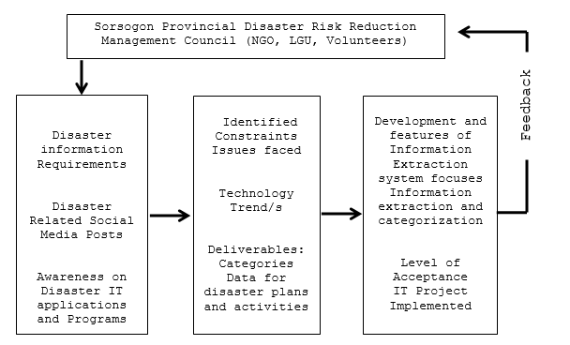
The process deals with the identification of disaster problems, issues, and deliverables for the disaster planning and activities.
To offer solutions to these identified inputs, methodologies shall be considered which includes interviews, data gathering tools, and evaluation of documents. The evaluation and assesment of the existing processes validate that there was a need for such study. The output of the study shall identify the features and determine the level of usability by the stakeholder. This shall position SPDRRMC in strategizing action plan to improve disaster management and response towards disaster operations.
Analysis of the existing information extraction system are also made to review the programs, modules and activities implemented.
Logical design. This section presents the System development framework, Class diagram, Sequence diagram, and Use-Case diagram of the proposed system. These diagrams shows the external and internal operational transaction of the system and also the interaction of the user. It also presents the logical flow of the system which starts from the input, process and output.
The proposed system used the django web framework that uses Model View Controller framework, but in a different way. Django uses this framework as Model View and Template, the template here means the layout or the html pages in the django framework, Figure 12 shows the Model View Template.
Figure 14
Django framwork Model View Template
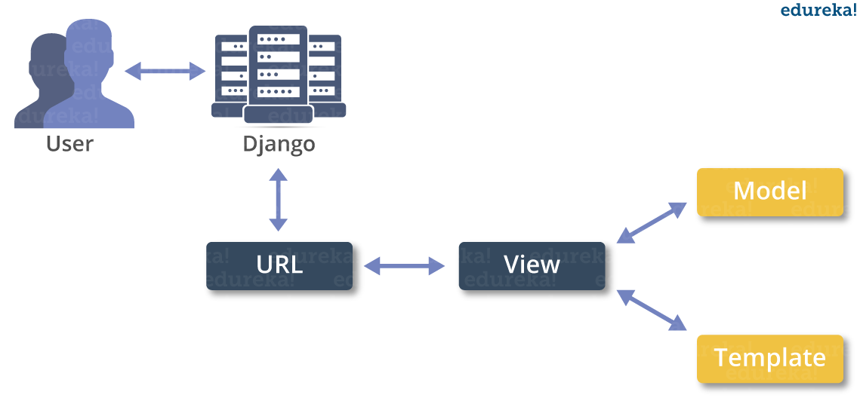
Django follows the MVC pattern closely, however it does use its own logic in the implementation. Because the “Control” is handled by the framework itself and most of the excitement in Django happens in models, templates and views. Model is the data access layer, this contains anything and everything about the data on how to access it, how to validate it, which behaviors it has, and the relationships between the data. While Template is the presentation layer, this layer contains presentation-related decision on how something should be displayed on a Web page or other type of document. And View is the business logic layer, this layer contains the logic that accesses the model and defers to the appropriate template(s). This bridge models and templates. The proposed system uses this framework for a reason this is because it uses Python as its programming language.
Figure 12 shows the class diagram of the proposed system that make use of Django web framerok. This contain the main project class and the relationship of project applications to the main project and the attributes that the class have. Each application that is inheriting from the Information Extraction Project class also known as Applications of that project has their own class this is called as models.
Figure 15
Class Digram of proposed system using Django Framework
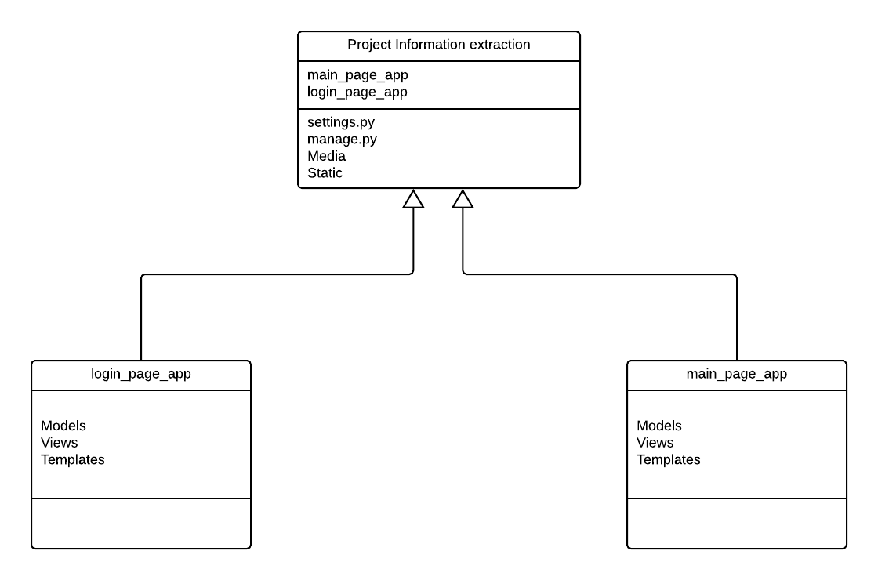
Login_page_app is an application from Project Information Extraction Class this inherit the settings and url mapping in the project class. This application has its own class called models, Figure 16 shows the class diagram and relationships of the login_page_app class.
Figure 16
Login Page App Class Diagram
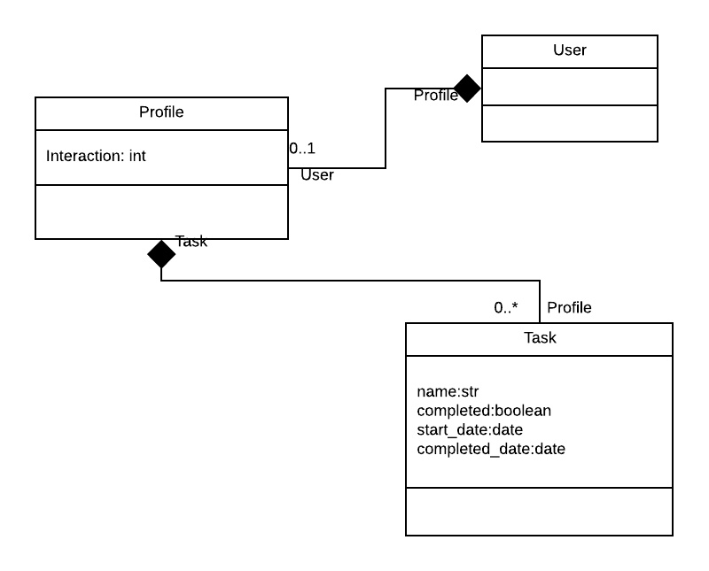
The above figure describe the structure of login_page_app class, attributes and associations to each other. User here is the Django module that do all the necessary security features to implement in a login system, including adding encryption to passwords, requiring system user to authenticate first before using a certain system functions.
Figure 17
Main_page_app Class Diagram
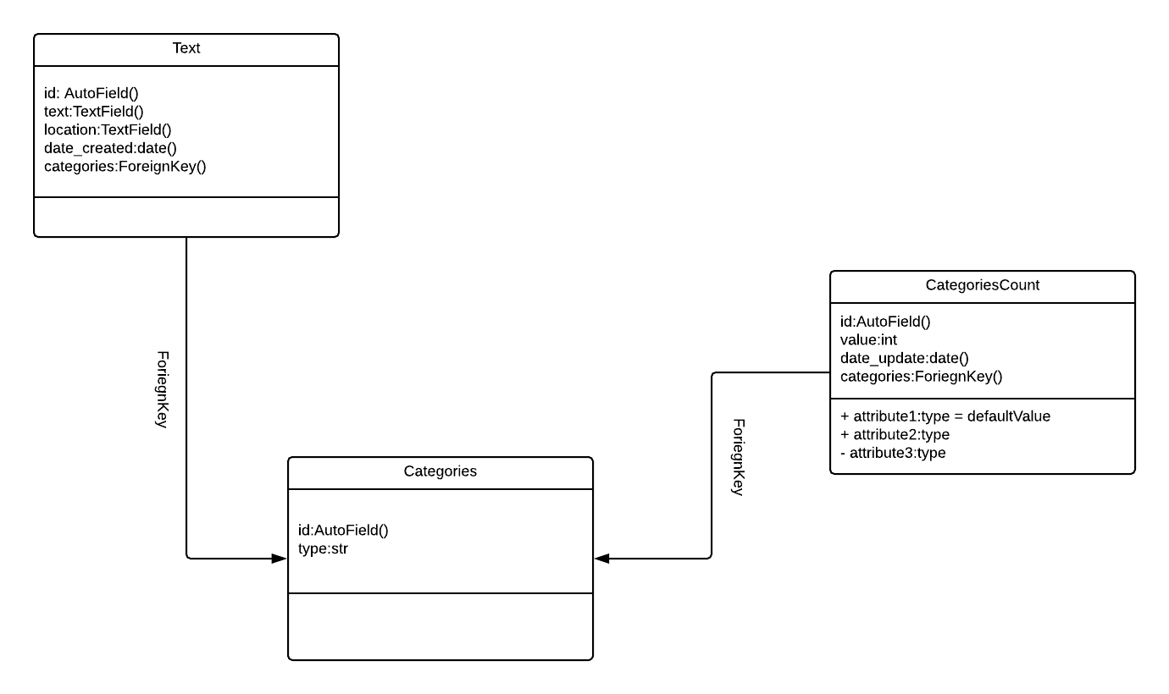
The above figure describe the structure of the main_page_app. It deals with classes, attributes, and opeartions and their associations to each other. This means that every extracted text from the social media has a category, and every category in the proposed system has a categories count. Figure 18 shows the full class diagram of the proposed system using Django framework.
Figure 18
Class diagram in Django framework of the proposed system
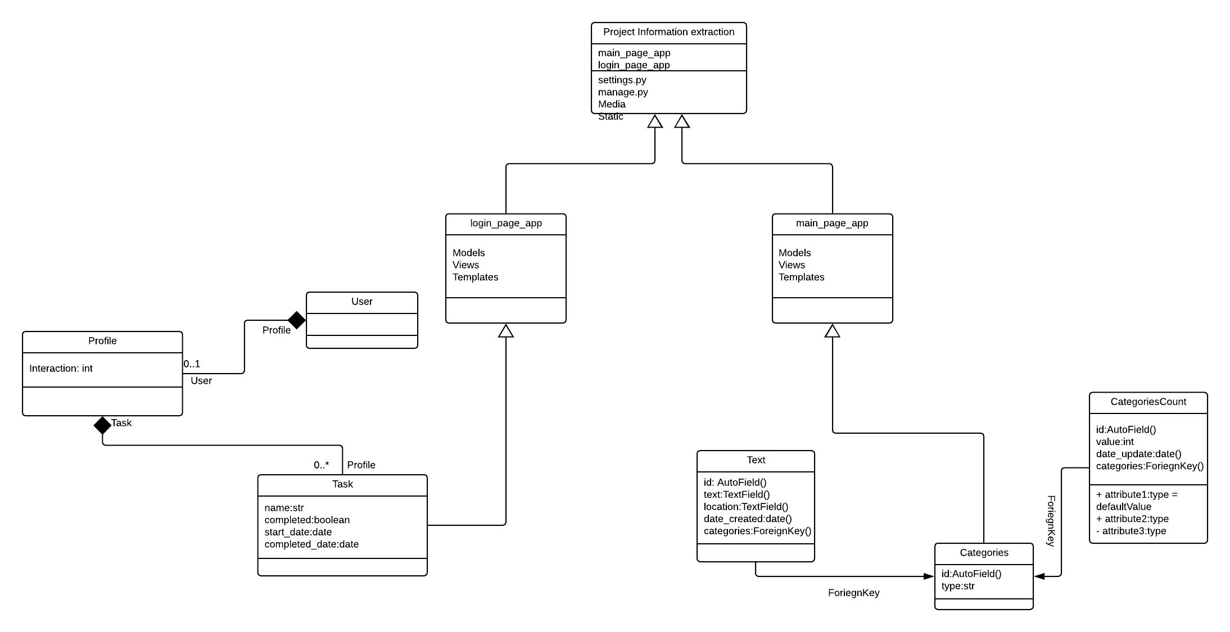
The above figure was used to describe the structure of the system. It deals with the objects, classes, attributes, operations and their associations to each other. In Django class diagram are separated by a Django app this is each major feature of the proposed system is separated by a Django app, and they are link together using a Django project.
Figure 19
Sequence Diagram
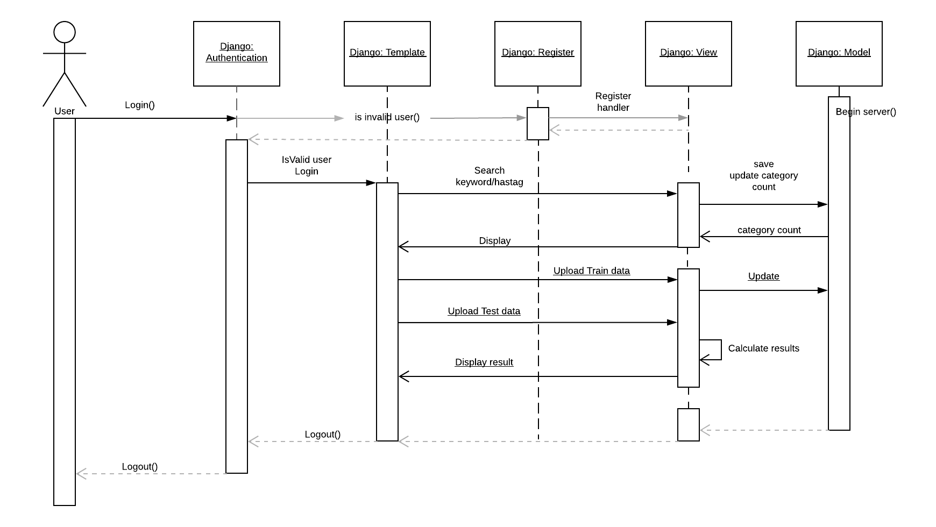
Figure 19 shows the Sequence Diagram of the system. It explains how these modules interact to each other and how the system response to a certain user transaction. The system operations transactions are divided into four major transactions which are Search keyword/Hashtags, Upload train data, upload test data, view data presentation and text categorization. This describe the patterns of communication among set of interacting objects which was represented by the user and the four transactions.
Figure 20
Use case diagram
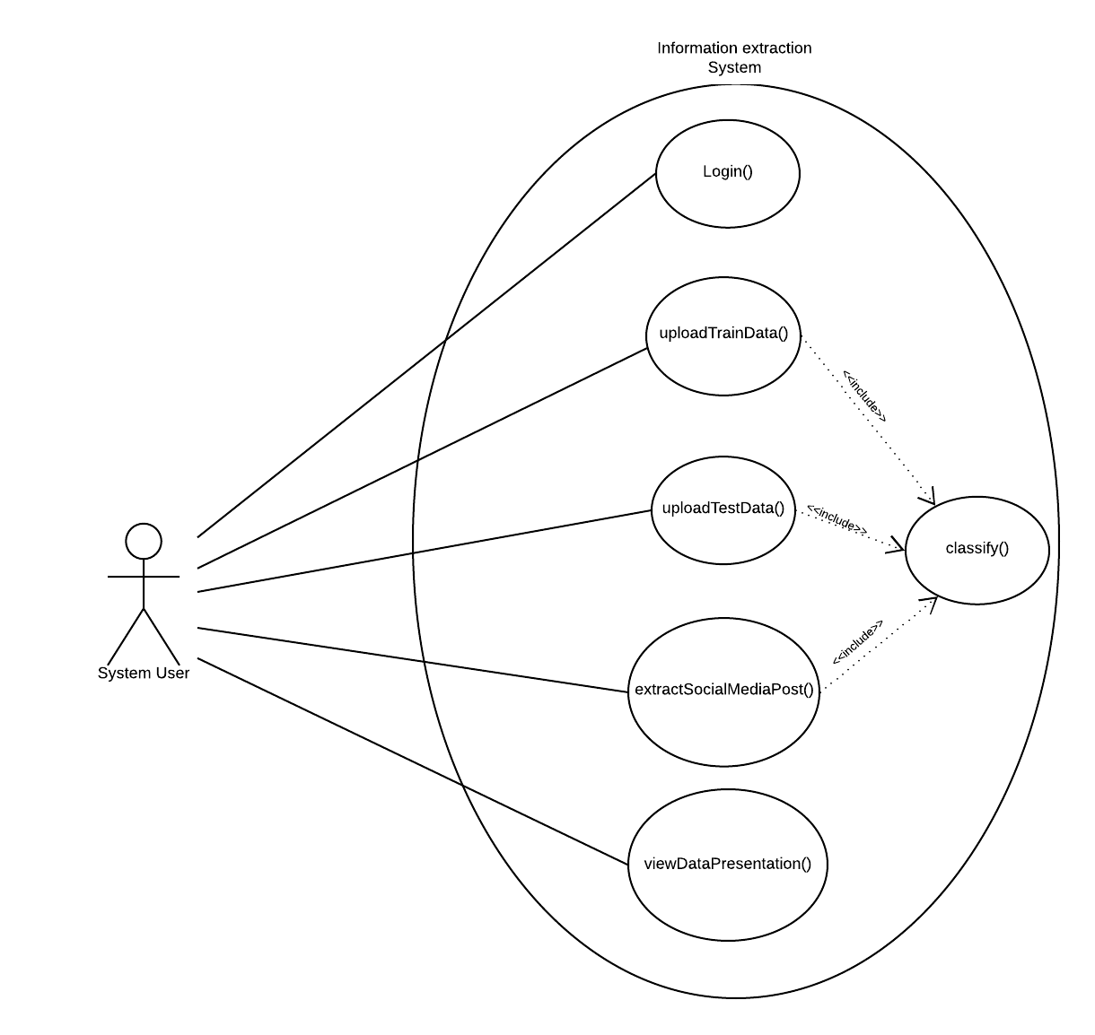
Figure 20 shows the Use case diagram for the system. The actor (system user) which have access to all the functionality of the system the system only require this user to authenticate itself using the login functionality in the system. The system user now can upload Train data to train the classifier of the system. Also upload Test data to test and compute the accuracy of the system. The system user also can extract data to social media posts by searching for keywords or hashtag, the extracted data can now be classify by the system and display the data in the system.
Physical Design
This sections presents the system architecture of the proposed system. The software architecture shows the software design pattern, and the user interface design of the proposed system.
Architectural design
It illustrates the network connectivity design were the hardware infrastructure setup, and the software requirements of the developed system. Figure 21 shows the system architecture of the proposed system.
Figure 21
System Architecture
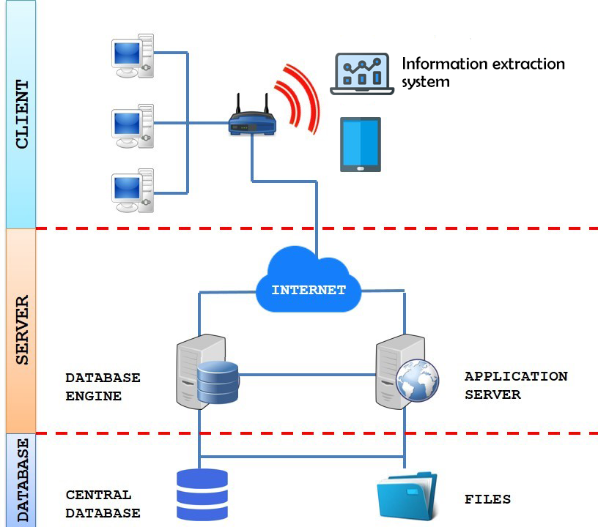
Figure 21 shows a three-tier architecture model which was used as the software design pattern of the system. The client tier is where the presentation is, this contains the information needed on the user’s perspective. This refers to the system’s graphical user interface. The logic layer (server), consist of the system functionalities that process the information based on the output needed. The data source layer or (database) is where the static file or required data that is used in the system.
Figure 22.1
Login page of the proposed system
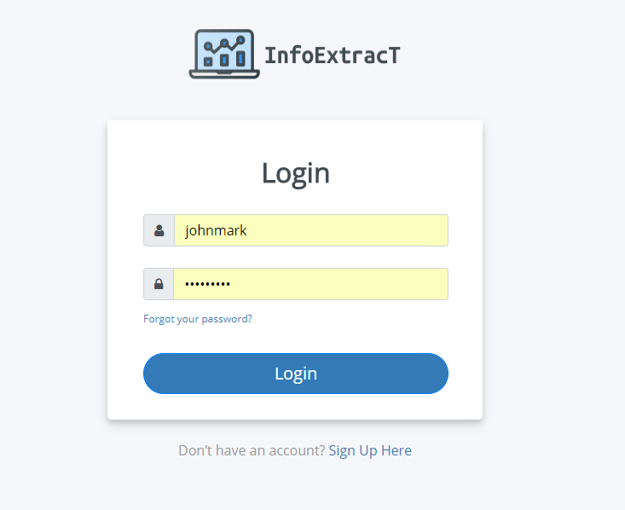
Figure 22.1 shows the login page for the system user to access the dashboard of the proposed system and login page for the Django built in admin dashboard for managing data storage.
Dashboard of the proposed system
This section shows the graphical user interface of the proposed system. Figure 23 shows the homepage or dashboard of the proposed system. This page present the important data that the proposed system generate, for example the post category count, post category count is the number post extract by the system that is classify in that category.
Figure 22.2
Login page for Django built in admin dashboard
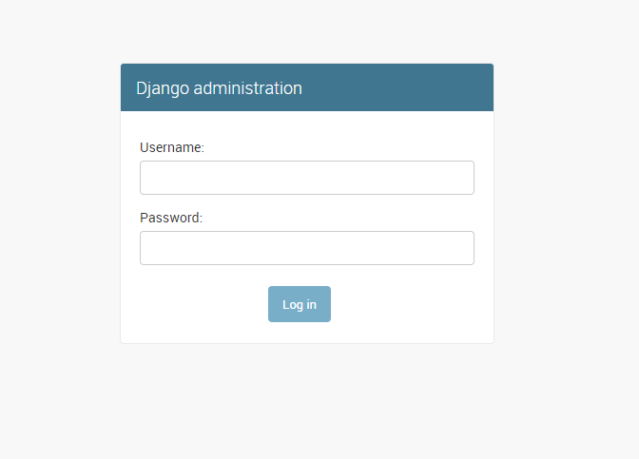
Figure 23
Home page of the proposed system
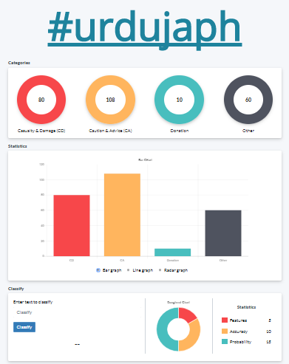
Figure 24
Upload train data
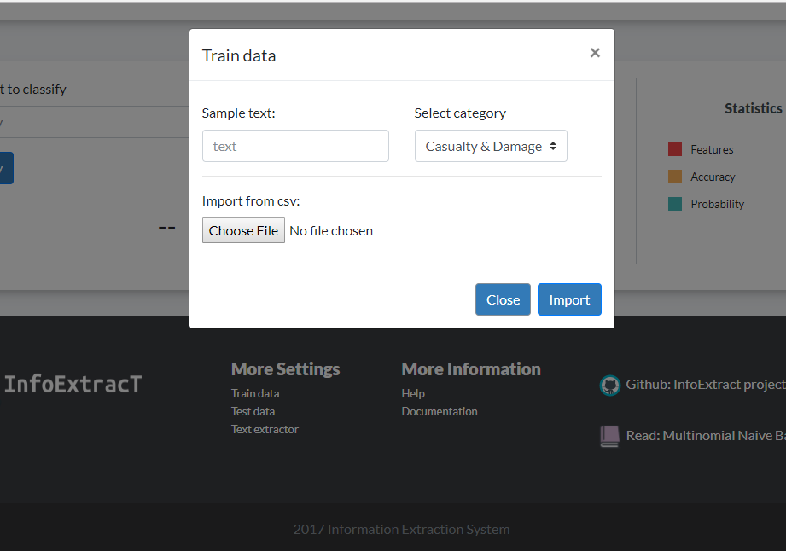
This figure shows the form where the system user upload the csv or upload manually a trained data in the proposed system. Trained data is used in the system to classify the extracted post in the proposed system.
Figure 25
Upload test data
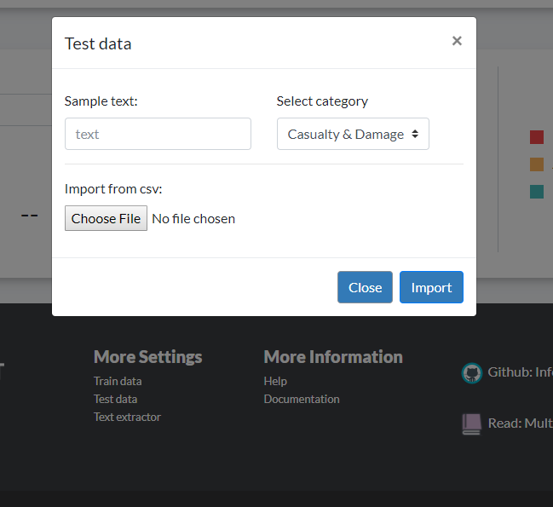
Figure 25 shows the form for uploading the test data in the proposed system this can be also done manually. The used of test data in the proposed system is to get the accuracy of the trained data.
Figure 26
Classify form of the proposed system
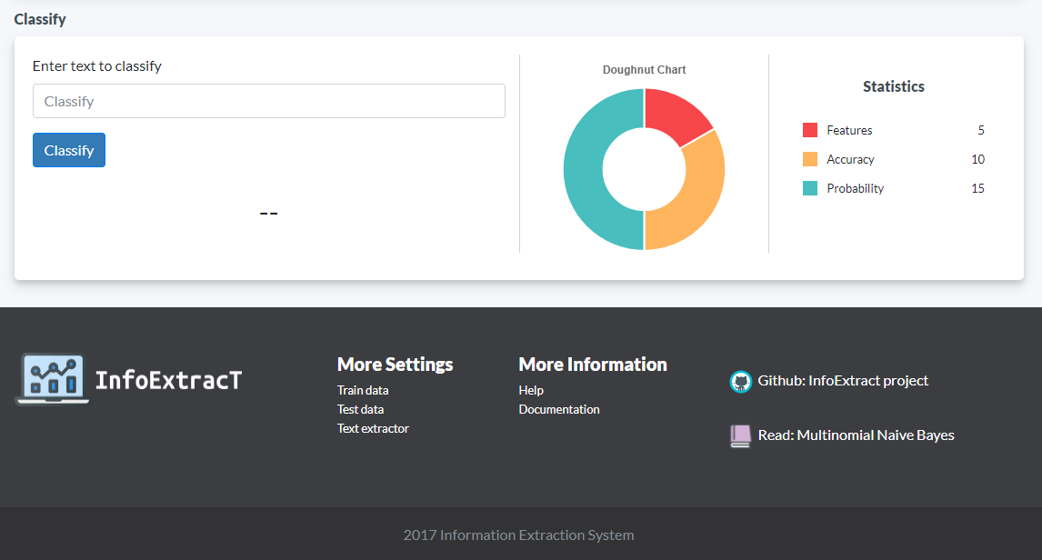
Figure 26 shows the form for testing the accuracy of the proposed system so the system users can check if the system is category classifier is working correctly.
Hardware and software Requirements of the proposed system
This presents the hardware and software requirements of the proposed system together with the descriptions. The requirements presented here are part of the available tools gathered.
Hardware Requirements
The hardware requirement describes the hardware specifications of the proposed system. Table 5 shows the list of needed hardware requirements which are used by the researcher during the development phase and was recommended for processor, HDD, memory, display card, monitor and internet connection speed. The system can run on any local internet service provider.
Table 6
Hardware Requirements
Item/s | Minimum system requirements
Processor  Disk Space  Requirement  Memory  Requirement  Display Card  Internet Connection | AMD Quad Core or Core i3 64bit  256GB  2GB DDR2  2GB built-in  Globe, Smart

Software Requirement
The software requirement is described in Table 6. It shows the software requirement of the system in order to ensure that its functionalities perform according to objectives.
The software requirement is composed of the programming language, front-end browser, graphics application, servers, operating system, back end application and other applications.
Table 7
Software Requirement
Item/s | Application, Language | Recommended
Scripting Language/ programming language | JavaScript, Python, Django | Equivalent
Backend (local server) | Python local server | Version 2.5
Front End (Browser) | Google Chrome, Firefox | Any browser
API | REST API | equivalent
Domain, web hosting | Pythonanywhere | equivalent
Windows other application | Windows 10, VS Code | equivalent

The above mentioned software are advised and recommended for installation in the computer that shall be host the system.

